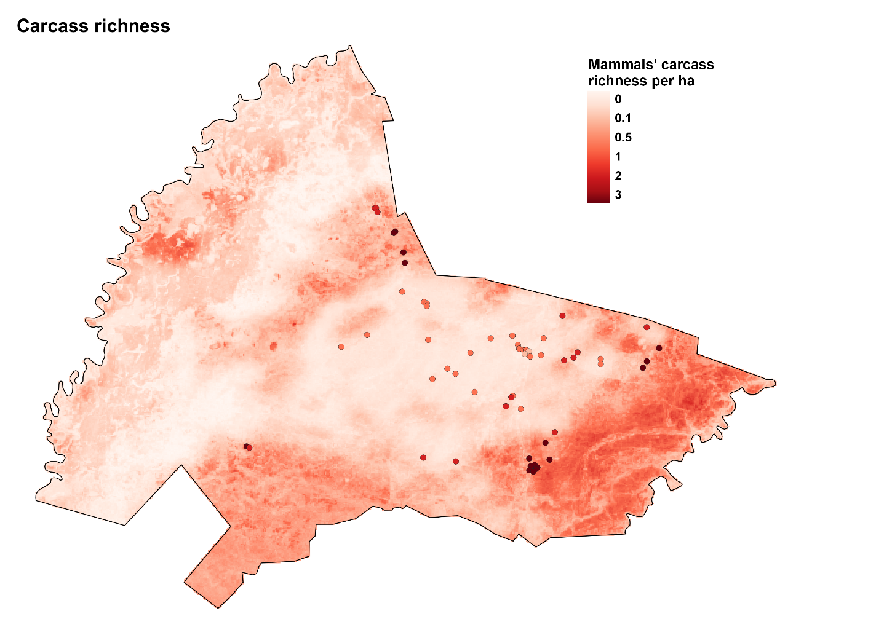

**Supplementary Figure S7.** Expected number of medium-large mammal species killed (per ha) by 2020 Pantanal megafires in the Sesc Pantanal Reserve, Brazil. Points represent artificial water bodies (AWB) where mortalities were expected to be higher.

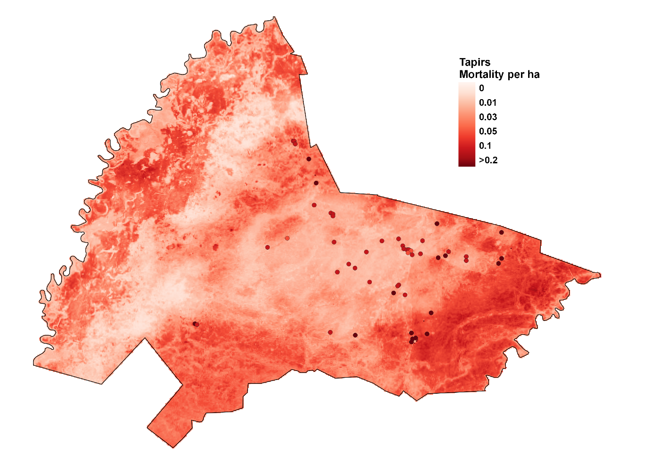

**Supplementary Figure S8.** Spatial prediction of Lowlad tapirs (Tapirus terrestris) mortalities after the Pantanal 2020 megafires at the Sesc Pantanal Reserve, Brazil. Points represent artificial water bodies ("tanques") where mortalities were expected to be higher.

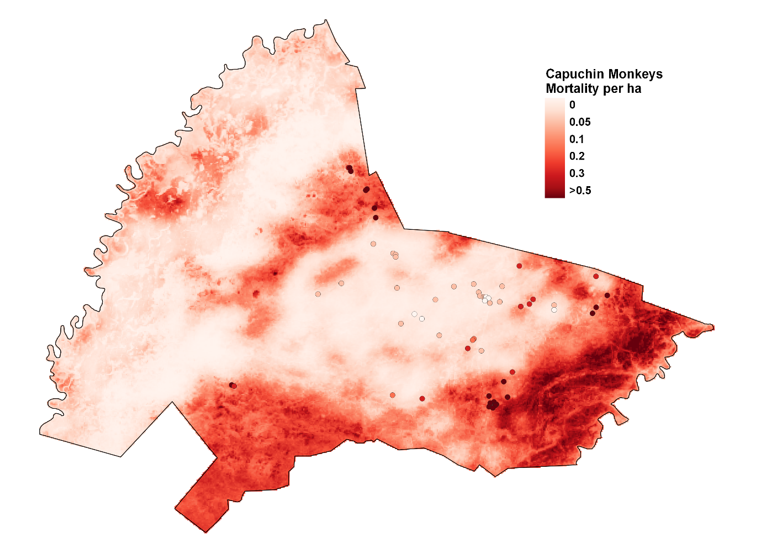

**Supplementary Figure S9.** Spatial prediction of Azara's capuchins (Sapajus cay) mortalities after the Pantanal 2020 megafires at the Sesc Pantanal Reserve, Brazil. Points represent artificial water bodies ("tanques") where mortalities were expected to be higher.

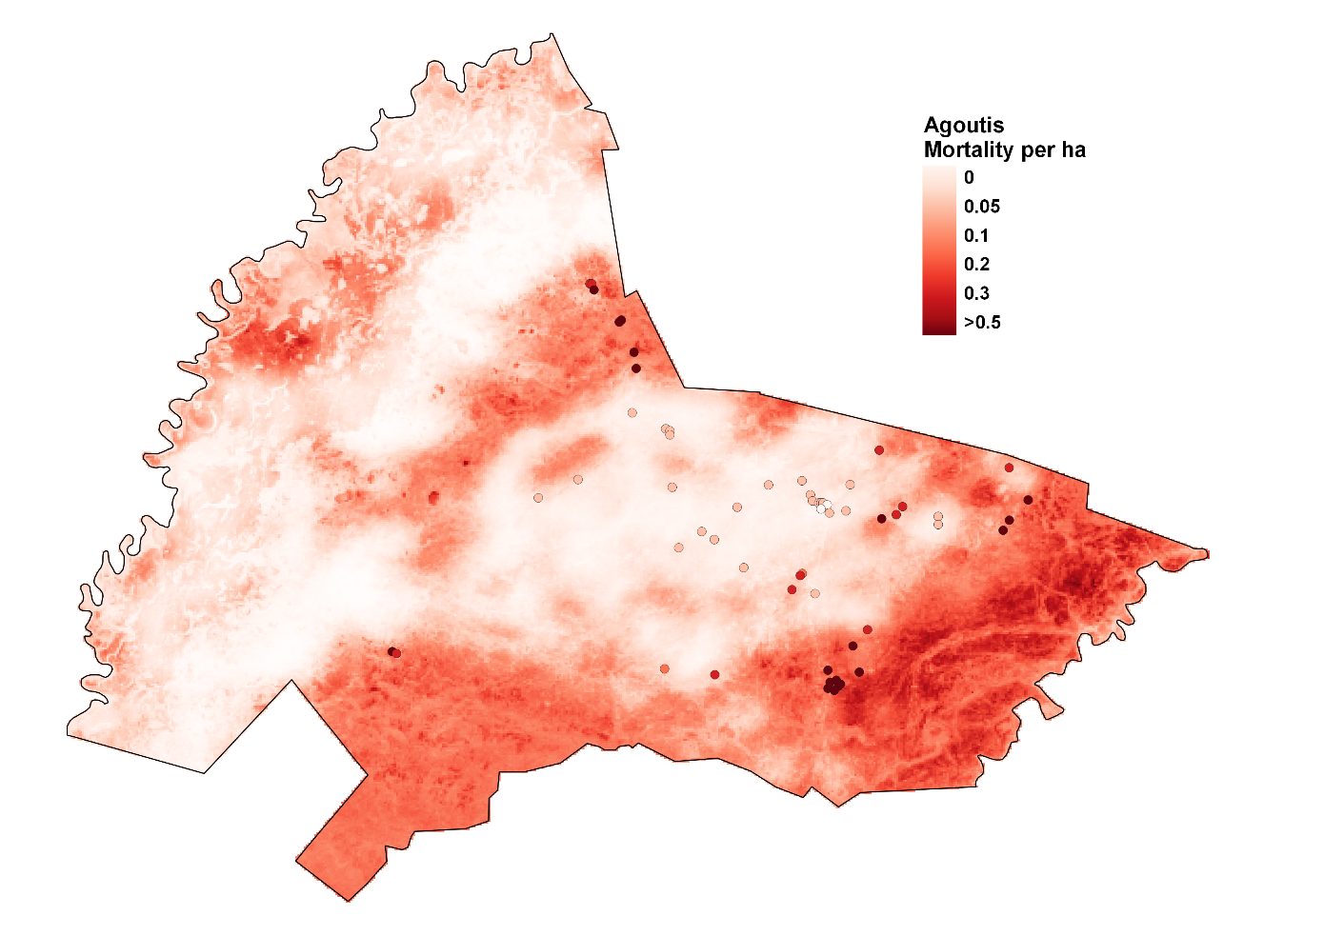

**Supplementary Figure S10.** Spatial prediction of Azara's agoutis (Dasyprocta azarae) mortalities after the Pantanal 2020 megafires at the Sesc Pantanal Reserve, Brazil. Points represent artificial water bodies ("tanques") where mortalities were expected to be higher.

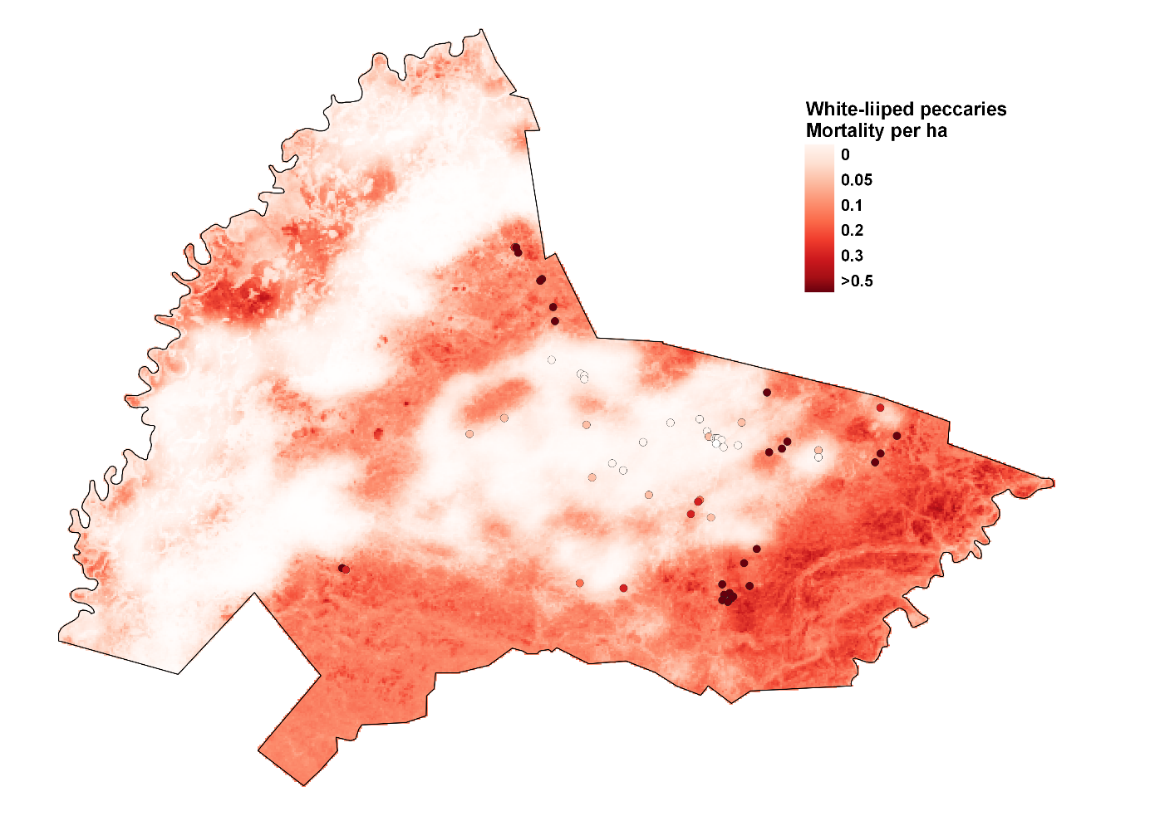

**Supplementary Figure S11.** Spatial prediction of white-lipped peccaries (Tayassu pecari) mortalities after the Pantanal 2020 megafires at the Sesc Pantanal Reserve, Brazil. Points represent artificial water bodies ("tanques") where mortalities were expected to be higher.

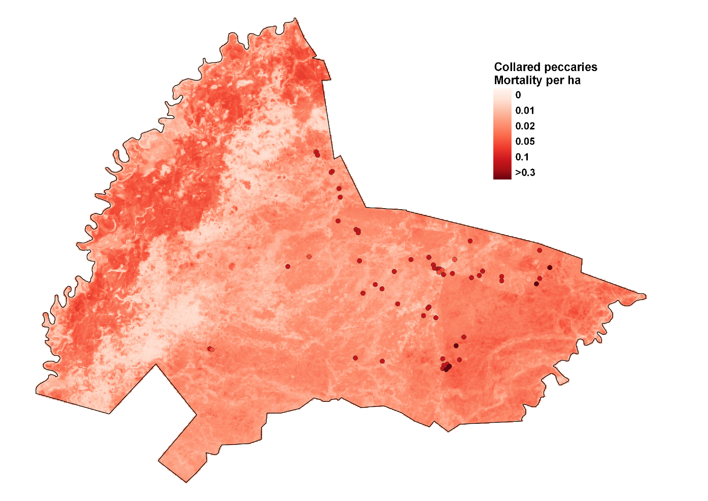

**Supplementary Figure S12.** Spatial prediction of collared peccaries (Pecari tajacu) mortalities after the Pantanal 2020 megafires at the Sesc Pantanal Reserve, Brazil. Points represent artificial water bodies ("tanques") where mortalities were expected to be higher.

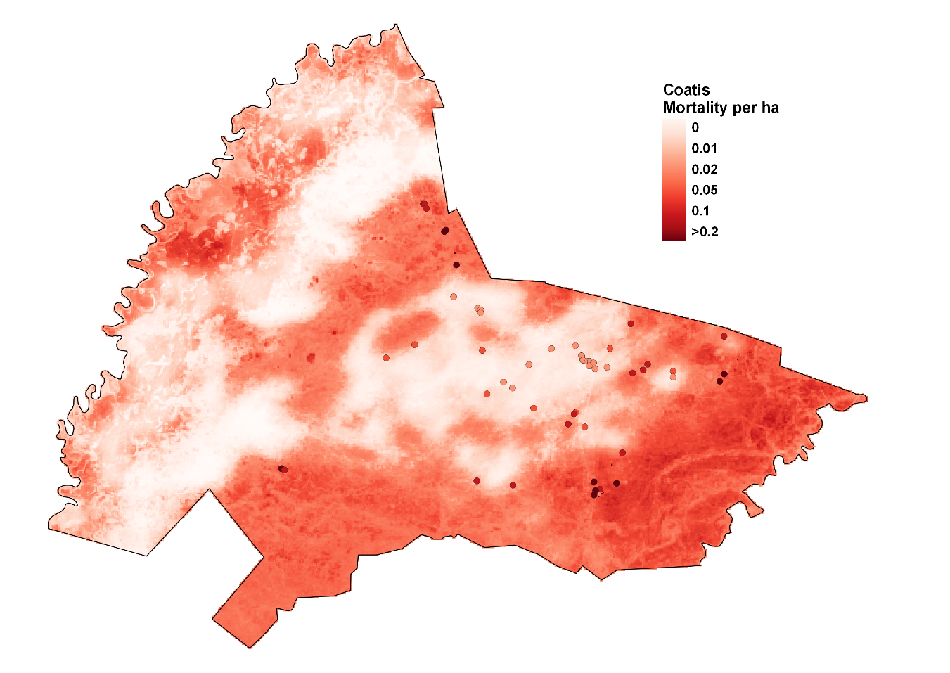

**Supplementary Figure S13.** Spatial prediction of South American coatis (Nasua nasua) mortalities after the Pantanal 2020 megafires at the Sesc Pantanal Reserve, Brazil. Points represent artificial water bodies ("tanques") where mortalities were expected to be higher.

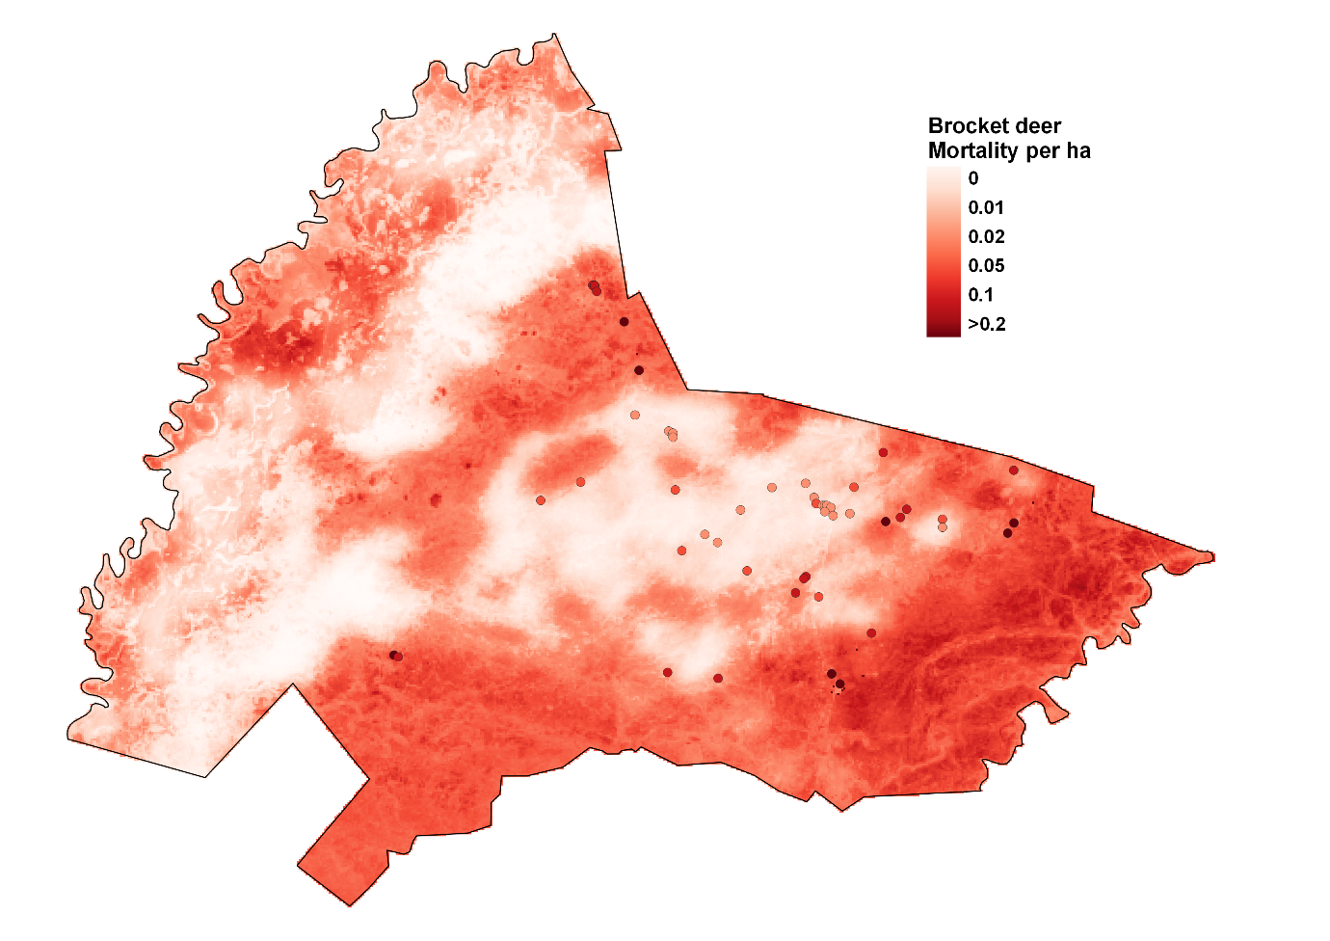

**Supplementary Figure S14.** Spatial prediction of brocket deers (Mazama and Subulo) mortalities after the Pantanal 2020 megafires at the Sesc Pantanal Reserve, Brazil. Points represent artificial water bodies ("tanques") where mortalities were expected to be higher.

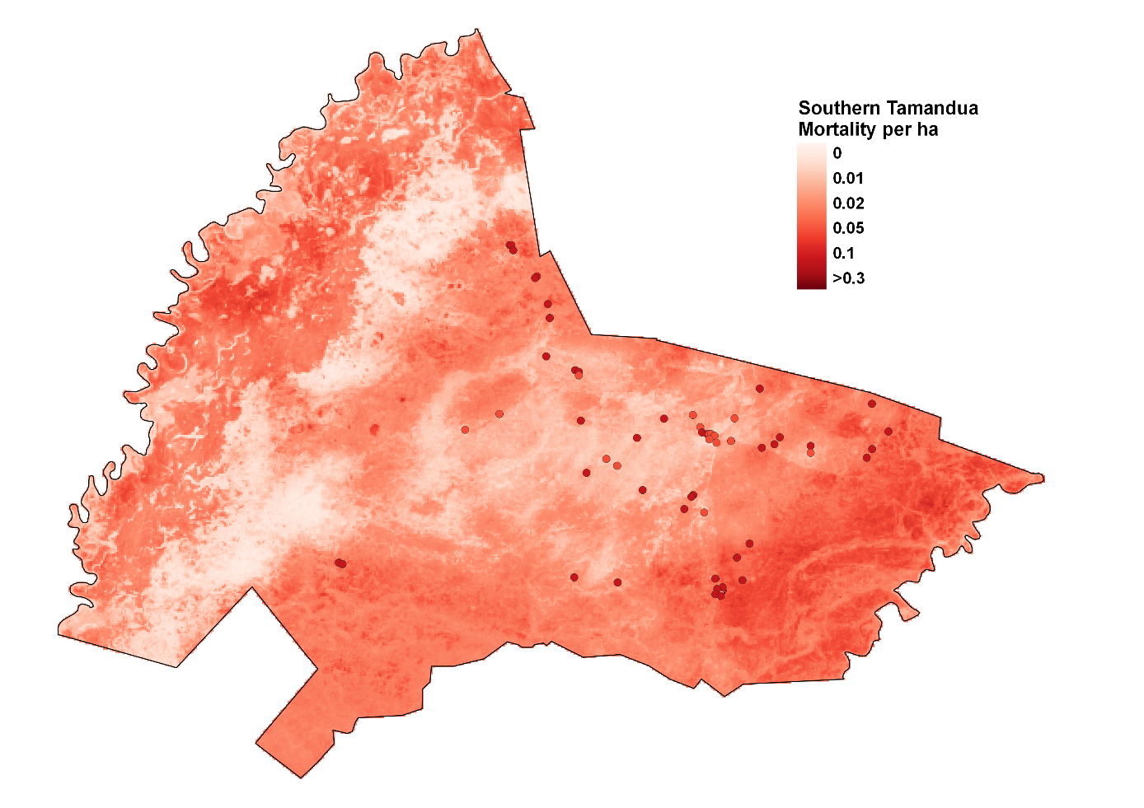

**Supplementary Figure S15.** Spatial prediction of Southern tamanduas (Tamandua tetradactyla) mortalities after the Pantanal 2020 megafires at the Sesc Pantanal Reserve, Brazil. Points represent artificial water bodies ("tanques") where mortalities were expected to be higher.

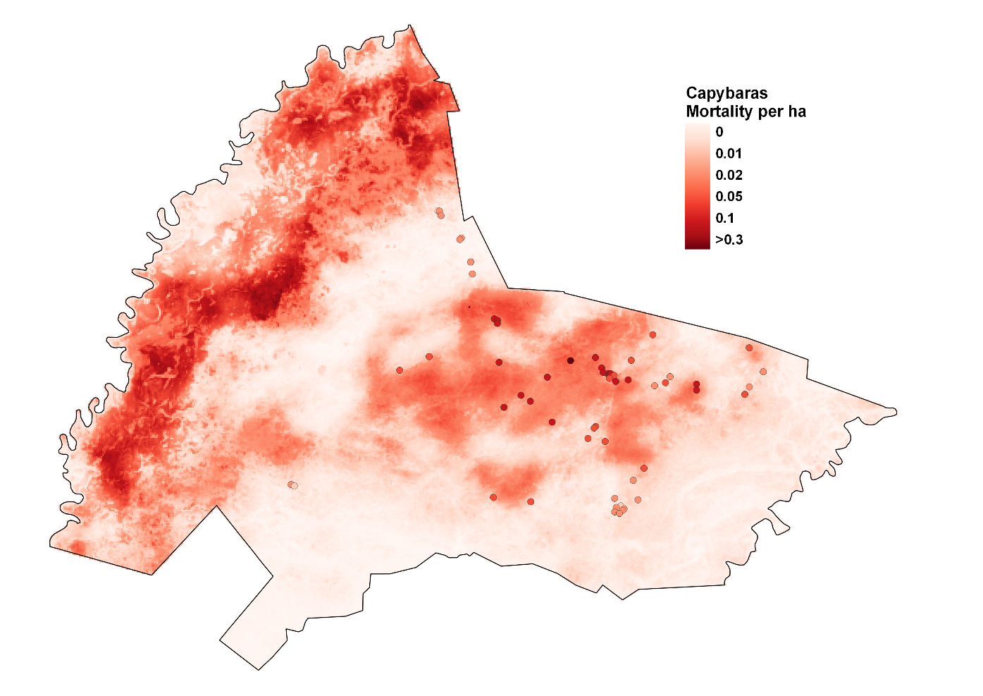

**Supplementary Figure S16.** Spatial prediction of capybaras (*Hydrochoerus hydrochaeris*) mortalities after the Pantanal 2020 megafires at the Sesc Pantanal Reserve, Brazil. Points represent artificial water bodies ("tanques") where mortalities were expected to be higher.